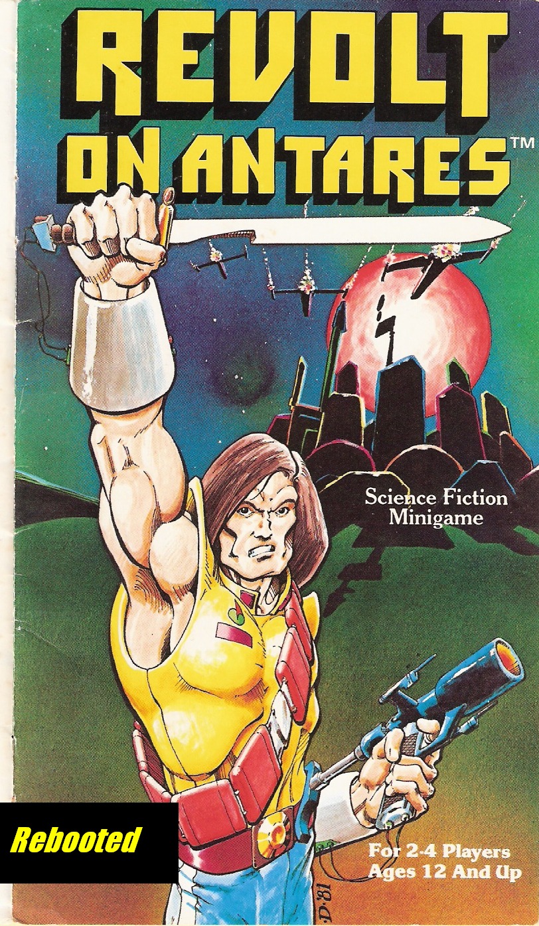

Revolt on Antares
Rebooted

This game is part of Project Cadmus, our effort to reproduce,
improve and distribute out-of-print games.

This rules set is a modification of the original rules created by Tom Moldavy and issued by TSR Hobbies Inc. in 1981 as “Revolt on Antares”. No copyright infringement is intended. Readers are encouraged to modify these rules, and forward their playtesting experiences and comments via Boardgamegeek.com

I'd like to acknowledge the great generosity of M.T., who gave me his copy of the original game. It turned out to be a gem, albiet a flawed one. I hope this version of the rules makes it possible for many more people to enjoy this game.

CONTENTS

Introduction 1

Game Components 2
Map 4, 5
Counters 2, 3

Movement
Rough Terrain 6
Stacking 6
Movement around the globe 7
Neutral hexes 7
All-sea hexes 7
Hovercraft 7
Jump Troops and Airjet Squadrons 8

Combat
Normal Combat 8, 9
How to conduct combat 9
Combat example 10
Airjet Attacks 11
Fortresses 11
Neutral houses 12
Movement after combat 12
Defeated leaders 12
Leader Combat 12

Replacements 13

Recruitment
Alliances 14
The 7 Houses 17
House Leaders 18
Other Leaders 22
Galactic Heroes 23

Artifacts 27

Scenarios
Basic Game: Revolt on Terra 32
The Silakka Invasion 35
Power Politics on Imirrhos 37

Relative House Strength Chart 40

Index

INTRODUCTION

Imhirrhos, ninth planet of the star Antares, lies on the edge of Earth's Imperial Terran Empire. As the Empire grows weaker, Imhirrhos boils with unrest and intrigue. The seven local ruling families (or “houses”) fight for power. Some want the Terrans to leave, others need Imperial support. A few know of the Silakka, an alien race waiting to invade...

In three different scenarios, a player can be a household leader, the Imperial Terran Counsul, or the leader of the Silakka aliens. Players recruit Galactic Heroes, raise armies, and use their hereditary psychic powers and ancient alien artifacts to gain control of Imhirrhos:
Antares 9!

Revolt on Antares has three scenarios: Revolt Against Terra, the multi-player Power Politics on Imirrhos, and
The Silakka Invasion.

The rules given for the basic game apply in all cases unless noted otherwise under the rules for the other two scenarios. It is reccomended that beginning players learn the basic game, Revolt Against Terra, first.

1.

GAME COMPONENTS

Counters. There are three types of counters (playing pieces) used in the game: Troop counters (power infantry, laser tanks, artillery, jump troops, hovercraft, and airjet squadrons), Leader counters (Faction Leaders and Galactic Heroes), and Artifact counters (powerful alien weapons). Most of the counters have two numbers printed on them.

The number to the left is the combat factor (how strong the counter is in combat). The number to the right is the movement factor (how far the counter can move each turn). Faction Leader and Galactic Hero counters will have the name of the leader or hero printed on them. Artifact counters contain the name of the device.

Throughout this rules booklet, the term “leader” will be used to denote both Faction Leader counters and Galactic Hero counters.

2.

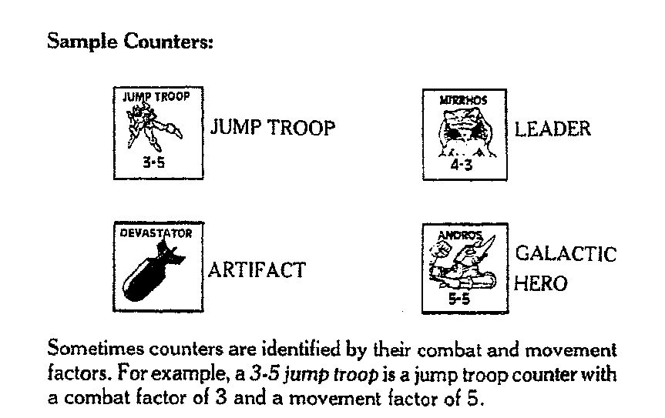

3.

Map. The playing map depicts the planet Imirrhos: Antares 9. Hexagons regulate movement; one hexagon is known as a “hex”. The map has nine colors. Dark blue represents Sea, brown Imperial Terran/Native territory, and the other seven colors show the holdings of each of the seven houses.

The map also contains two types of symbols, terrain and economic. Note that although there are three different symbols used for terrain, each terrain symbol has the same effect upon movement.

The numerous economic symbols are literally symbolic. Each economic symbol has the exact same effect upon game play. Variation is there simply to add aesthetic interest to the map.

The numbers at the map edges are intended to facilitate movement around the globe, and can also be used to keep track of turns, by employing a coin or other marker.

4.
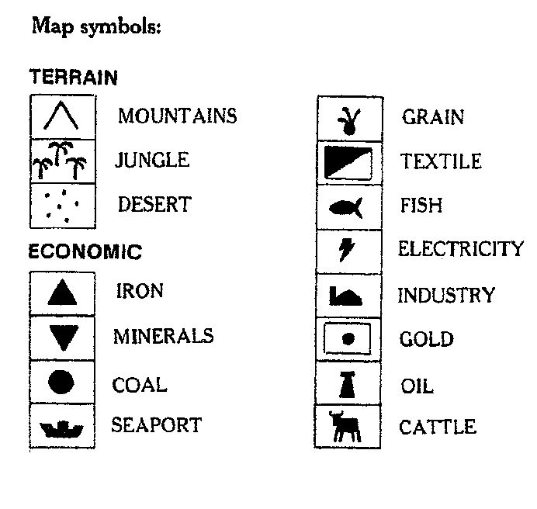

Each house fortress is indicated by a unique hex symbol. For example, House Orsini is represented by this hex:

5.

MOVEMENT

During each player's movement phase, the player may move some, none or all of his counters.. The number in the lower right corner of the counter is the movement factor. Moving a counter into a hex costs one movement factor. Movement factors cannot be “saved up” or given to other counters.

Rough Terrain. There is an additional cost of one movement factor for moving a counter into any rough terrain hexes (mountain, desert or jungle) during a turn. This penalty is only applied once per turn for a counter, no matter how many rough terrain hexes, or how many different types of rough terrain hex, are moved through.

Counters cannot move into or through a hex containing enemy counters. Counters may move through hexes containing friendly counters as long as no more than three counters (plus special artifacts) end their movement in the same hex.

Stacking. No more than three counters may be placed (“stacked”) in the same hex at any time.
The only exceptions are the four artifact counters with no movement or combat factors: the Devastator, Dimensional Plane, Energy Drainer, and Field Generator counters. These four artifacts must always be stacked with another counter, and will move at the rate of the counter they are stacked with.

Leader and Hero counters do count toward the stacking limit. Allied counters of different colors may stack together, as long as they are controlled by the same player.

6.

Counters in the same hex may move together at the rate of the slowest counter in the stack (exception: see Hovercraft) or may move seperately, as desired.

Movement Around the Planet. The map represents a globe. Thus, counters may move off the east or west map edges directly to the opposite edge. However, counters may not travel between the north and south edges of the map in this manner.
The hexes on the eastern and western edges have been numbered to help with this special movement.

Neutral hexes. Counters may never pass through or end movement in hexes belonging to houses not yet allied with one side or another. Exception: Airjets, Jump Troops and Leader/Hero counters that function as such, may pass through neutral hexes, but may not end movement there.

All-Sea Hexes. Faction Leaders, most Galactic Heroes, infantry, tank and artillery counters may not move or
attack across all-sea hexsides unless transported by a hovercraft.

Hovercraft Movement. Hovercraft can cross land or sea hexes freely, and end movement on any hex (respecting stacking limits). Hovercraft may also be placed with up to two additional counters. All these counters may then move at the hovercraft's movement rate. (exception: hovercraft may never transport airjet counters). However, a counter may not move with a hovercraft and on its own in the same turn. Hovercraft must pay the rough terrain cost (see pg. 6).

7.

Jump Troop and Airjet Squadron Movement. Jump Troops and Airjet Squadrons (and Leader/Hero counters that function as such) do not suffer any terrain penalties. They may also move through hexes containing enemy counters. These units can move across neutral hexes and all-sea hexes as long as they do not end their movement there. Airjets and jump troops may never end movement stacked with enemy counters.

COMBAT

Normal Combat.
The moving player may attack enemy counters by moving next to them, and declaring that he is attacking.

After moving and declaring attack, the attacker may then look at any of the defending counters in any or all hexes adjacent to his. If desired, the attacker may then choose to call off the attack. Note that the moving player may not examine stacks he is adjacent to, and then move away. (However, a clever player might choose to move out of his hex, and then return to his origin, after which he would be allowed to examine the stacks he both started, and ended up, next to.)

Note that attacking units that end movemet as a stack must attack as a stack. Individual units within the stack may not attack seperate targets. All units within an attacking stack must attack a single target, combining their combat factors. Note that this “single target” may be an enemy stack, with all of its combat factors combined also.

8.

The moving player may attack an enemy from several different hexes at once, as long as all of the attacking counters are next to the defending counters.

All counters within a target stack must be attacked at one time, as if they were a single unit.

No counter can attack or defend more than once each combat phase.

Note that normal combat may be affected in various ways by Artifact counters or the powers of Faction Leaders or Galactic Heroes. Leader and Hero counters lend their printed combat factors to their side in normal combat.

To conduct a combat, the attacker first declares whether any special leader or hero powers will be used. The defender then does the same.

The attacker and defender then each add up how many combat factors they have in combat. Then each rolls a die and adds this number to the total. The side with the highest number wins. The loser takes off some counters (of his choice) so that the total number of combat factors taken off is equal to the difference between the two numbers. (This may mean that the loser must take off more combat factors than the actual difference.)
Faction Leader and Galactic Hero counters must be chosen last in this process.

9.

Combat Example: The Rebel player decides to attack a stack of Terran counters with several stacks of Rebel counters during the Rebel player combat phase. The Rebel player is considered the “attacker” for this combat, and the Terran player is the “defender”. The combat factors of all the ounters for each side are added. Suppose the totals are 18 for the Rebel player and 14 for the Terran player. Each player rolls a die--- the Rebel player rolls a 3 and the Terran player rolls a 1. These numbers are added to each player's combat factor total, giving the Rebel player a grand total of 21 (18 + 3) and the Terran player 15 (14 + 1). The Rebel player wins by 6 points, so the Terran player loses the combat. He must remove counters totalling at least 6 combat factors from the defeated counters ( for example, a 4-3 infantry, and a 2-8 hovercraft.)

Airjet Attacks. Airjets may make only one attack per turn, as follows: Airjet counters may either move adjacent to an enemy hex and attack, or choose to attack any enemy-occupied hex they pass through during the movement phase. If an Airjet chooses to attack while passing through a hex, combat is resolved during the movement phase. If the Airjet survives, it may use any remaining movement points to continue traveling.

An Airjet may never conduct both types of attack in one turn. Airjets may never stack with enemy counters, except during an attack. Airjets may stack with friendly units, within stacking limits.

Airjets may never end movement in all-sea hexes, and they may not be transported on hovercraft.

10.

Fortresses. Each house fortress (including Starport Imirrhos) has defensive force shields. All counters defending inside any fortress hex have their combat factors doubled for defense. For example, a 3-5 jump troop counter in a fortress defends with a combat factor of 6 and attacks with a combat factor of 3.

Note that when a player enters an enemy fortress, he does not claim that house's replacement points for himself, but he does prevent that house's remaining points from being spent until the fortress is reclaimed by either the original owning player's units, or allied units.

Neutral Houses. Counters belonging to neutral houses may not be attacked until the house allies with a player.

Movement After Combat. If all enemy counters in a hex are taken off (including leaders who retreat) the winner may move up to three attacking counters into the vacated hex.

Defeated Leaders. Faction Leaders and Galactic Heroes defeated in normal combat are not simply taken from play like other counters. For each defeated leader, the player rolls a die, and applies results as follows:

A roll of 1 or 2 means that the leader has been killed and is removed from the board permanatly. It cannot be replaced.

11.

A roll of 3 or 4 means that the leader is wounded. Remove the leader from the board. It may re-enter play at no cost after three turns have been completed. (Thus, a leader wounded on Turn 3 would re-enter on that player's Turn 7 replacement and recruitment phase.) The players may choose to place the wounded leader counter next to the appropriate numbered hex marked along the edge of the board, as a reminder.

A roll of 5 or 6 means that the leader was forced to retreat. Move the leader counter to the nearest hex of a friendly color that is unoccupied by any other counters. The leader may not move or attack for one turn.

Note that all defeated leaders will still participate in Leader Combat immediately following normal combat, as described below. Exception: Leader counters within the blast radius of the Devastator Artifact are permanantly destroyed when it is used, and they do not enter into leader combat after regular combat occurs.

LEADER COMBAT

If both the attacker and defender have leader counters in combat, the leaders must fight a special combat in addtion to normal combat. All leader counters are considered equal for purposes of leader combat. Special powers do not apply, with one exception: Corvus Andromeda, Galactic Hero.

Each player rolls a die, and the player with the highest total wins. A tie means that neither leader wins nor loses.

Leader combat is fought until one side has no more leaders in combat, or until all of the leaders have fought once. A leader who is outnumbered by multiple enemy leaders may have to fight several times until he either loses or manages to beat each of the enemy leaders. Note that a player may lose the normal troop combat, but still win the leader combat.

12.

Leaders defeated in leader combat are removed from the board permanantly.

REPLACEMENT AND RECRUITMENT

Replacement. Normal troop counters lost through combat may be replaced in the replacement and recruitment phase at a cost of one replacement point per counter (not one point per combat factor). The number of replacement points that each house has during the game is marked on the map in the box next to the house fortress, and is listed in this booklet's references section. The Terran player begins the game with 10 replacement points.

Replacements are cumulative. For example, a player who begins the game as Imperial Terra (10 replacement points) and makes an alliance with House Edistyn (4 replacement points) would then have a total of 14 replacent points (10 + 4) which could be spent to replace any counters lost during the game, including leaders, heroes, and allies.

Note that replacement points are expended as they are used. The only way to acquire additional replacement points during the game is by claiming another neutral house as your ally.

Note that when a player enters an enemy fortress, he does not claim that house's replacement points for himself, but he does prevent that house's remaining points from being spent until the fortress is reclaimed by either the original owning player's units, or allied units.

Color-coded chits have been provided to keep track of replacement points. When spent, these should be immediately returned to the bank.

13.

Wounded leader counters may re-enter play at no cost after three turns have passed. Dead leaders and destroyed Artifact counters may never be replaced.

Recruitment. Galactic Heroes may be recruited by both players. During the replacement and recruitment phase, the player should roll a die for each house under his control (for this purpose, Imperial Terra is considered a house.)

A roll of 1 means that a hero has been recruited. Heroes are chosen at random from the face-down hero counter pile. If all available heroes have already been recruited, no other hero recrutment is possible. Heroes do not cost any replacement points to recruit and may be placed on any friendly fortress or economic hex.

ALLIANCES

Choosing allies. Each turn during the alliance phase, two houses that began the game as neutrals will join one side or the other. First the Rebel player, then the Terran player, may choose one neutral house as an ally. All counters belonging to that house will come under the control of the player who chooses it. Thus, all houses will be on one side or the other by the end of turn 3.

14.

The Seven Houses. Imperial Terra prefers to leave local governments alone as long as the taxes are paid on time. The actual rulers of Imirrhos are seven clan-like families, descendents of the original human colonists. The seven houses are:

House Orsini (purple)

House MacKenzie (light blue)

House Kinrabe (light green)

House Fitzgerald (red)

House Sessedi (orange)

House Brazanga (dark green)

House Edistyn (yellow)

Each house leader posesses a special psychic power.

15.

House Leaders

Messalina Orsini has the power of fascination. In combat, there is a 50% chance she can force one enemy troop counter of her choice (not a leader or hero) to fight on her side for that turn. The target must be in a hex adjacent to Messalina.

Roll a die; a 1, 2 or 3 means success. 4, 5 or 6 means failure (nothing happens)

The controlled troop counter may be used by Messalina as a casualty.

16.

Black Dougal MacKenzie has teleportation power. He can teleport any one MacKenzie counter (including his own counter, but no allies, mercenaries or artifacts) to any chosen hex that is unoccupied by enemy counters. He may do this each turn during the MacKenzie player's movement phase. Once teleported, the unit may not move any further that turn.

Barracuda Kinrabe has the power to cause hallucinations. If the stack he is with loses a battle, roll one die. A roll of 1, 2 or 3 means that the enemy attacked an illusion and Kinrabe's stack is unhurt. On a roll of 4, 5 or 6 his stack suffers losses normally.

17.

Simon Fitzgerald can create ion waves. They soothe the fears and raise the spirits of all troops attacked with him, raising each counter's combat factor by +1. (The combat factor of the Simon Fitzgerald counter already includes this effect, it's strength is 6).

Ariton Sessedi has long-distance telepathy. When rolling for recruiting Galactic Heroes, he is successful on a roll of 1 or 2 instead of just on 1.

18.

Catherine “the Mad” Braganza can summon lightning. The lightning strikes for 6 combat factors that are added to the attack her stack is making. Unfortunately, her control of the lightning is not always exact.

A die must be rolled: on a roll of 1, 2, 3 or 4 the lightning strikes the enemy target, but on a roll of 5 or 6, the lightning strike her stack (causeing it to subract 6 combat factors from it's attack).

Nureb Khan Edistyn has precognition. When his stack is in combat, he rolls two dice instead of one, and the best of the two rolls is used. This bonus does not apply to leader combat.

19.

Other Leaders

Mirrhos. Popular leader of the original, primitive inhabitants of Imirrhos. Each native counter stacked with him gains a +1 bonus to its combat factor due to high morale.

Ward Serpentine. Counsul for Imperal Terra on Imirrhos. Commander of the Beserkers of the Imperial Guard, a 6-3 power infantry batallion.

20.

Magron the Invincible. Alien Leader of the Silakka invasion force, and commander of a 7-4 laser tank corps.

Galactic Heroes

Andros. Android of unknown alien manufacture. Andros can summon and command the Phantom Regiment, a 5-5 corps of other-dimensional warriors who move across terrain like the Dimensional Plane Artifact.

They travel through rough terrain without penalty. They may move through sea hexes, or even end their movement on a sea hex. The +2 movement bonus is already reflected in the movement factor of 5. The Andros/Phantom Regiment counter does not confer its abilities to units stacked with it.

21.

Corvus Andromeda. Intergalactic Assasin. He has a bonus of +1 to leader combat only.

Doctor Death. An outlaw who creates zombie-like troops from the dead. He can take immediate control of any two troop counters that die in a battle he is in, be they friendly or enemy troops. No replacement points are needed for these counters and they must always remain stacked with Dr. Death. Normal stacking rules apply. If Dr. Death is killed or wounded, the “zombie” counters are removed from play (as if destroyed) and can be replaced normally by the original owner.

22.

Emerald Eridani. Commander of the Emerald Company, a mercenary 7-4 laser tank corps.

The Iron General. Cyborg commander of a
7-4 laser tank corps.

Lyra Starfire. Intergalactic adventuress and pilot of
a 5-10 airjet squadron.

23.

The Nullspace Kid. Youthful intergalactic adventurer and pilot of a 5-10 airjet squadron.

Subadai O'Reilly. Commander of O'Reilly's Raiders,
a 6-3 power infantry batallion.

Skarn 3. Alien mercenary captain of a
4-5 jump troop squad.

24.

Tovan Palequire. Intergalactic smuggler and weapons runner. The player who recruits Tovan receives an additional 2 replacement points immediately to represent the cargo of Tovan's ship. If Tovan becomes a casualty, these points are not lost.

ARTIFACTS

An unknown alien culture once flourished on Imirrhos. The cluture destroyed itself, leaving behind a number of artifacts. (Note that the color of the Artifact counters has nothing whatsoever to do with house colors)

Except for the Devastator, all artifacts are reusable.
Artifacts with no combat factor are destroyed if the counter(s) they are stacked with are destroyed.

Note that the Devastator, Dimensional Plane, Energy Drainer, and Field Generator must always be stacked with another counter.

25.

The Devastator destroys all life not protected by force shields in a one-hex radius (ie, the hex it is detonated in, plus the six hexes around it). Note that all house fortresses have defensive force shields.

The Devastator can be used only once per game during the combat phase of the owning player, and is left on the board to mark the devastated area.

Leaders in the area are rolled for as if they had lost in Leader combat. Neither side receives victory points for economic hexes that have been devastated, nor can any counter move over or through the devastated area.

The Devastator and the Field Generator will cancel each other out. If used against each other, both artifacts will be detroyed without the loss of any other counters.

Note that the Devastator must always be stacked with at least one friendly unit, or it is destroyed.

26.

The Dimensional Plane adds +2 to the movement factor of all counters stacked with it and allows travel through rough terrain without penalty.
Counters stacked with it may move at sea or end their movement in all-sea hexes (and can be attacked normally).

Note that the Dimensional Plane must always be stacked with at least one friendly unit, or it is destroyed.

The Energy Drainer drains power from attacking forces. All counters attacking the stak containing this artifact attack with a strength of only 2 combat factors each, regardless of the type of counter. This artifact can only be used when defending; it adds no bonus if attacking. It does not affect penalties or bonuses due to leaders' psychic powers.

Note that the Energy Drainer must always be stacked with at least one friendly unit, or it is destroyed.

27.

The Field Generator can be used to either cancel a fortress force shield (the defenders combat factors will then not be doubled on defense) or to crate a force shield that acts like a fortress (counters stacked with it will have their combat factors doubled for defense). The Field Generator can only be used for one of these functions per turn; it may not be used to both attack a fortress and to create a force shield on the same turn. The Field Generator is incapable of generating a force shield within a fortress hex.

Note that the Field Generator must always be stacked with at least one friendly unit, or it is destroyed.

The Force Cannon is an artillery counter with a combat factor of 8 and a movement factor of 1. It can move through rough terrain at 1 hex per turn.

28.

The Sonic Imploder is an artillery counter with a combat factor of 7 and a movement factor of 2.

The UFO is an alien flying craft which acts as a 5-10 airjet squadron.

29.

THE BASIC GAME:
REVOLT AGAINST TERRA

This is a two-player scenario. One player is the house leader who starts the revolt (Rebel), and the other player represents the Imperial Terran Counsul (Terran).
The grey Silakka alien counters are not used and should be set aside.

Setup. Artifact counters and Galactic Hero counters are placed face-down in two seperate piles, and thoroughly mixed. The Rebel player places one Artifact counter
face-down on each house's fortress hex, without looking at them.

Artifact couters remain face-down until a player takes the owning house as an ally. When a player gains control of a house, he may then look at the Artifact. The Artifact remains face-down; the other player will not know what it is until it is used. It then remains face-up for the rest of the game.

The Rebel player chooses the house he wishes to play, plus one allied house. These houses are in revolt.
The Terran player then chooses any other one house as the Terran ally. The last four houses will remain neutral.

The Rebel player then sets up the counters of each neutral house as follows: the leader, a face-down Artifact, and the counter with the greatest combat factor are placed on the house fortress hex. The rest of that house's counters are placed face-up, one per hex on any economic symbol of their house color.

30.

Once the four neutral hexes are set up, the Terran player places the starting Terran forces plus the counters of the Terran allied house. Starting Terran forces are:

One 3-5 jump troop
One 7-4 laser tank batallion
One 4-10 airjet squadron
One 2-8 hovercraft
Ward Serpentine, commanding a 6-3 power infantry batallion

These counters may be placed anywhere on Terran territory (any brown hex, including Starport Imirrhos).
The counters of the Terran allied house may be placed on any hex of that house's color.

The Rebel player places the counters of the two houses he controls. Counters of each house must be set up in hexes of that house's color. The Rebel player now chooses one Galactic Hero from the face-down pile of hero counters. Unlike Artifact counters, Galactic Hero counters are not kept secret once taken. The hero may start the game in the territory of either house, and may be stacked with friendly units.

Victory Conditions. At the end of 10 turns, the player with the greatest number of victory points wins the game. Victory points are awarded for every economic-symbol and fortress hex controlled (occupied) at the end of the game. Each economic hex scores 1 point; each fortress, 3 points. Starport Imirrhos scores 10 points. If a hex is unoccupied, it belongs to the player who controlled that hex's house color, and is scored accordingly.

31.

Sequence of Play

1. Rebel player moves
2. Rebel player combat (including Leader Combat)
3. Terran player moves
4. Terran player combat (including Leader Combat)
5. Rebel player replaces troops and recruits Heroes
6. Terran player replaces troops and recruits Heroes
7. Rebel player chooses ally from remaining houses
8. Terran player chooses ally from remaining houses
9. Mark off one turn

Repeat steps 1-9 for 10 turns

(Note that each scenario has its own sequence of play)

THE SILAKKA INVASION

Two-player scenario. All the counters are used. Game length is 10 turns, with victory points scored just as in the Basic Game (see pg 32). One player is the Silakka invader, the other player is the Terran. The Terran player places the counters of the seven houses following the Basic Game rules. The starting Terran counters are placed wherever the Terran player wishes.

The Galactic Hero counters are separated into two face-down piles. One pile contains Dr. Death, Skarn 3 and Corvus Andromeda. The other contains the remaining heroes. The two players decide who controls the houses as follows: The Silakka player chooses an allied house first, then the Terran player chooses an allied house. The players alternate choices until all houses have been chosen.

32.
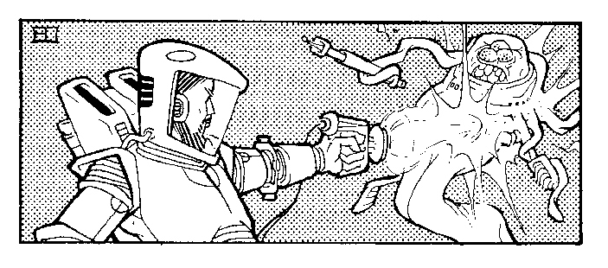

The Silakka player places the Silakka counters anywhere on the map (except all-sea hexes) and places the native troop counters plus Mirrhos anywhere on the brown hexes. The Silakka player will move first.

The Silakka have 12 replacement points, plus those of their allied houses. The Terrans have 10 replacement points plus those of their allied houses. Silakka replacements arrive at any friendly economic hexes, following stacking rules.

The only Galactic Heroes the Silakka player may recruit are Dr. Death, Skarn 3 and Corvus Andromeda. Except for the natives, the Terran player receives reinforcements and replacesments as in the Basic Game. No alliance phase is necessary, since all allies are chosen before Turn 1. Otherwise, turn sequence is the same as in the Basic Game.

Victory Conditions. At the end of 10 turns, the player with the greatest number of victory points wins the game. Victory points are awarded for every economic-symbol and fortress hex controlled (occupied) at the end of the game. Each economic hex scores 1 point; each fortress, 3 points. Starport Imirrhos scores 10 points. If a hex is unoccupied, it belongs to the player who controlled that hex's house color, and is scored accordingly.

33.

POWER POLITICS ON IMIRRHOS

This scenario is for 2, 3 or 4 players. Game length is 8 turns. Each player plays one or more houses, fighting against the other houses for control of Imirrhos. The players roll for first choice (highest roll chooses first) and then alternate choosing allied houses until all the houses have been divided among the players as equally as possible. Remaining houses are diced for similarly.

Setup is as in the basic game, Revolt on Terra.

Terran territory is treated as permanantly neutral. However, all counters may freely move through Terran territory, with the exception of Starport Imirrhos. This prohibition/exception includes jump troops and airjets.

The Native counters, Ward Serpentine counter, and Magron counter are not used. The Silakka and Terran counters are placed face-down in one pile to the side of the map and thoroughly mixed. These represent off-planet mercenaries, and are divided equally among the players as follows: Players roll for first choice, highest roll choosing first, and then alternate choosing until the counters have been divided as equally as possible. Any remaining counters are diced for in a similar manner.

The order of play is determined at the beginning of
each turn by rolling a die. The player having the highest roll will move and have combat first, followed by the player having the next-highest roll, etc.

34.

Players begin the game with zero replacement points.
There is no alliance phase necessary in this scenario.

Eliminated mercenary troop counters are placed face-down in a common “dead” pile, while elmininated House counters are placed in a seperate piles, by color, face-up. Galactic Heroes are recruited just as in the basic game.

At the end of Turn 3, each player counts how many economic and fortress hexes he controls. Note that if an economic or fortress hex is unoccupied, the points accrue to the player who conrols that house color. Each player gains 1 replacement point for every economic hex controlled, and 3 points for every fortress controlled.
In a 4-player game, the player who started with only one house receives double points (2 points per economic hex, 6 points per fortress). These are the only replacement points given to the players during the game.

These points may now be used to replace destroyed counters during a player's replacement and recruitment phase each turn. House counters must all be replaced before any mercenary counters may be replaced. House counters cost 1 replacement point per counter to redeem. Mercenary counters cost 2 replacement points. Only one mercenary counter may be redeemed per turn per player.
If there are no mercenaries left in the dead couner pile, no more may be redeemed.

35.

When more than two are playing, active diplomacy and wheeling and dealing on the part of the players is encouraged.

At the end of Turn 8, victory points are assigned as per the basic game, 1 point per economic hex controlled, 3 per fortress hex controlled.

36.

ANTARES COUNTER LIST
This chart displays the relative strengths of the houses
and units in the game.

Replacement
points

House Orsini (Purple) 4

5-3 Messalina
4-3 (x3) Power Infantry
2-8 (x2) Hovercraft
_________
21

House MacKenzie (Light Blue) 5

5-3 Black Dougal
6-4 Laser Tank batallion
4-3 (x3) Power Infantry
2-8 Hovercraft
____________
25

House Kinrabe (Light Green) 4

5-3 Barracuda
6-4 Laser Tank Batallion
4-3 Power Infantry
3-5 (x2) Jump Troops
2-8 Hovercraft
___________
23

37.

House Fitzgerald (Red) 4

6-3 Simon
6-4 Laser Tank Batallion
4-3 (x2) Power Infantry
3-5 Jump Troops
2-8 Hovercraft
____________
25

House Sessedi (Orange) 5

5-3 Ariton
6-4 Laser Tank Batallion
4-3 (x2) Power Infantry
2-8 Hovercraft
____________
21

House Braganza (Dark Green) 5

5-3 Catherine
6-4 Laser Tank Batallion
4-3 Power Infantry
3-5 Jump Troop
2-8 Hovercraft
___________
20

38.

House Edistyn (Yellow) 4

5-3 Nureb Kahn
6-4 (x2) Laser Tank Batallion
4-3 (x2) Power Infantry
3-5 Jump Troop
_____________
28

Imperial Terra (Brown) 10

6-3 Ward Serpentine
7-4 (x2) Laser Tank Batallion
5-3 (x2) Power Infantry
3-5 (x3) Jump Troops
2-8 Hovercraft
4-10 (x2) Airjet Squadrons
____________
45

Natives (Tan) No Reinforcements

4-3 Mirrhos
3-2 (x2) Native Infantry
2-2 (x3) Native Infantry
___________
16

39.

The Silakkans (Grey) 12

7-4 Magron
5-5 (x6) Powered Infantry
3-5 (x3) Jump Troops
_____________
46

Galactic Heroes

5-5 Andros
3-3 Corvus Andromeda
3-3 Doctor Death
7-4 Emerald Erdani
7-4 Iron General
5-10 Lyra Starfire (airjet squadron)
5-10 Nullspace Kid (airjet squadron)
4-5 Skarn3
6-3 Subadai O'Reilly
3-3 Tovan Palequire

House Leaders

6-3 Ward Serpentine
7-4 Magron
4-3 Mirrhos
6-3 Simon
5-3 All Other Leaders

40.

INDEX

Airjets 10

Alliances 14

Artifacts 6, 26
Devastator 26
Dimensional Plane 26
Energy Drainer 26
Field Generator 28
Force Cannon 28
Sonic Imploder 29
UFO 29

Combat 8 combat example 10
how to conduct combat 9
leader combat 9, 12, 13
movement after combat 11

Defeated leaders 11

Economic hexes 4, 5

Fortresses 5, 11, 13

Galactic Heroes
Andros 21
Corvus Andromeda 22
Doctor Death 22
Emerald Erdani 23
Iron General 23
Lyra Starfire (airjet squadron) 23
Nullspace Kid (airjet squadron) 24
Skarn3 24
Subadai O'Reilly 24
Tovan Palequire 25

House Leaders 2, 6, 11, 16

Hovercraft 7

Jump troops 8

Movement 6
airjet movement 10
after combat 11
around the globe 7
neutral hexes 7
stacking 6

Neutral Hex 7

Neutral House 12

Recruitment 14

Replacements 13

Scenarios
Basic Game, Revolt on Antares 31
The Silakka Invasion 34
Power Politics on Imhirros 36

Sea Hexes 7

Shields 11, 28

Stacking 6, 7

Terrain 4, 5, 6

Credits to the original game, Revolt on Antares:

Designer: Tom Moldavy
Development: Kevin Hendryx
Editing: Jon Pickens, Patrick L. Price, Stephen D. Sullivan,
Art: Jeff Dee, David S. LaForce, Erol Otis, Jim Roslof,
Bill Willingham
Typesetting: Roxanne M. Perry
Playtesting and Able Assistance: Tom Moldavy, Jon Pickens,
Brian Pitzer, Mike Price, Evan Robinson, Edward G. Sollers

Antares 9 boils with unrest and intrigue....

This planet, called Imirrhos by its people, has long been ruled by Imperial Terra. Although local power is held by seven large family Houses, all important matters are controlled by the Empire. Now, however, several clan houses are plotting to rise up and throw off Imperial Rule.

Each ruling House is controlled by a leader posessing a unique Psionic power. Imperial Terra has overwhelming military might, and the aid of the original natives. Lurking in the wings are the mysterious Silakka aliens, with their own agenda. Various Galactic Heroes will throw in their lot with one side or another, and who knows which powerful ancient Alien Artifacts you may discover?

Which faction will you choose
to wrest control of Antares 9?

Revolt on Antares Rebooted contains 3 scenarios for
2, 3 or 4 players. Game length is 30 to 90 minutes.

